



Annual Early Years Service Profile Guidelines

2019/2020

Contents

Introduction 3

Accessing the Service Profile 5

Accessing via PIP: 5

Accessing via Early Years Portal: 6

Navigating and saving the Service Profile 7

Note on completing multiple Service Profiles 8

1 Service details 9

General 9

Disability/ Equality/ Inclusion 10

2 Capacity and attendance 12

Service type 12

Weekly fees 15

3 Staff: Managerial 17

4 Staff: Working with children 21

5 Ancillary staff (those NOT working directly with children) 25

Deleting or editing the number of staff members 27

6 Vacancies/ Turnover (staff working directly with children only) 28

7 Covid-19 Activities 30

8 Declaration 30

9 Submission of Service Profile 31

# Introduction

The 2019/2020 Early Years Service Profile is the primary data source on the Irish early learning and care and school-age childcare sector. It is developed and published by Pobal on behalf of the Department of Children and Youth Affairs

The Annual Early Years Service Profile plays a central role in informing policy development, assessing the impact of policy change and providing a comprehensive national analysis of over 4,500 early learning and care and school-age childcare services throughout Ireland.

The survey, which has been running for over 17 years, highlights key trends within the sector on key issues, such as capacity, staff and costs. The continuation of this survey in 2020 is more important than ever given the challenges COVID-19 have presented for this sector. The information you provide is essential for future policy development as well as short term emergency planning. It will also ensure that we maintain an accurate, up-to-date and evidence-based profile of the early learning and care and school-age childcare sector in Ireland, and that we can capture a profile of services before the COVID-19 closures in March. This means that, in time, when the survey rolls out again, we can objectively assess the impact of COVID-19 on individual services and on the sector as a whole.

**COVID-19 notice**

**This survey covers the period up to the closure of early learning and care and school-age childcare services on 12th March 2020. All responses (including staff details, wages and fees) should therefore reflect how the service was operating up to this date.**

Pobal and the DCYA appreciate you taking the time to complete this survey, which has been shortened this year to include only the most critical information needed for Government policy and planning. We understand that the sector is experiencing unprecedented challenges due to COVID-19, and that their focus is placed on working towards the phased reopening of services in line with the Roadmap for Reopening Society and Business. We also acknowledge and sincerely thank the services for their participation in the recent survey, which was rolled out to inform plans on reopening.

**About the survey**

This annual survey is developed and published by Pobal on behalf of the Department of Children and Youth Affairs. The content of the survey is also informed by a stakeholder consultation, which was conducted in partnership with the Early Years Forum.

The data collected will allow for in-depth analysis of the sector across a range of headings including:

* Service detail and provision
* Capacity and attendance
* Staffing (numbers, qualifications, staffing retention, level of turnover etc.)

By providing the most up-to-date national data on the sector, we are able to support a range of key stakeholders in their planning and analysis. For instance, data may be shared with:

* Government Departments (e.g. Department of Education and Skills, Early Years Inspectorate)
* Organisations conducting research and analysis on behalf of Government Departments
* Statutory agencies (e.g. Tusla Early Years Inspectorate)
* Better Start Early Years Specialist Service
* City/County Childcare Committees
* Local Authorities (to inform local planning and development priorities)

Summary data will also be provided to the following organisations for research and statistical purposes:

* Voluntary Childcare Organisations
* Central Statistics Office
* OECD
* Third Level Institutions

Data from this survey may also be combined with findings from other surveys of the early learning and care and school-age childcare sector conducted on behalf of the Department of Children and Youth Affairs.

We have made every effort to keep the survey concise and relevant. Only questions that relate to key policy and planning priorities are included in the survey.

**Completing the survey:**

**A service profile should be completed for each facility i.e., one for each DCYA reference number.**

**How long will it take to complete the service profile?**

The length of time it takes to complete the survey depends on the size of the service, the number of staff and number of children enrolled. It is expected to take approximately one hour. The survey will save so you can complete it in more than one sitting before final submission.

**Why does the survey look different to previous years?**

This year’s survey was developed on a new platform and so the layout and format of some questions has been changed.

**Can I complete the service profile through Irish?**

Based on feedback from the sector, we had intended to offer the service profile through Irish this year. This unfortunately has not been possible due to resource constraints arising from COVID-19. Pobal and the DCYA continue to work towards this goal for future years.

**Who can we contact for assistance?**

If you experience any difficulties accessing or completing this survey, please contact the Pobal Helpdesk at [EYPC@pobal.ie](mailto:EYPC@pobal.ie). While we are unable to accept calls at the moment due to COVID-19 constraints, we can arrange a call back for you at a time that suits.

# Accessing the Service Profile

## Accessing via PIP:

Log into the PIP Portal and under ‘***My Services***’, click on ***View details*** for relevant ***DCYA Ref*** (if more than one service).

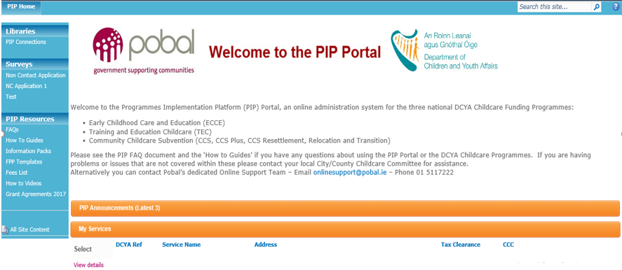

Under ***Service Details***, on right hand side of the page, click ***Service Profile Survey***:

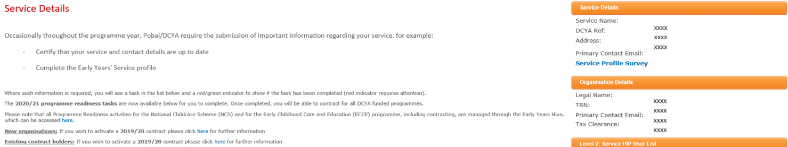

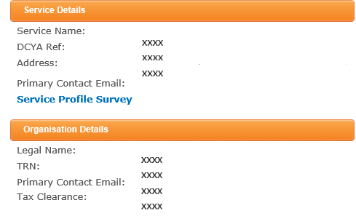

(As noted above, a service profile should be completed for each facility, i.e. one for each DCYA reference number.)

## Accessing via Early Years Portal:

Log in to the Early Years portal homepage. And click ***Service Profile Survey:***

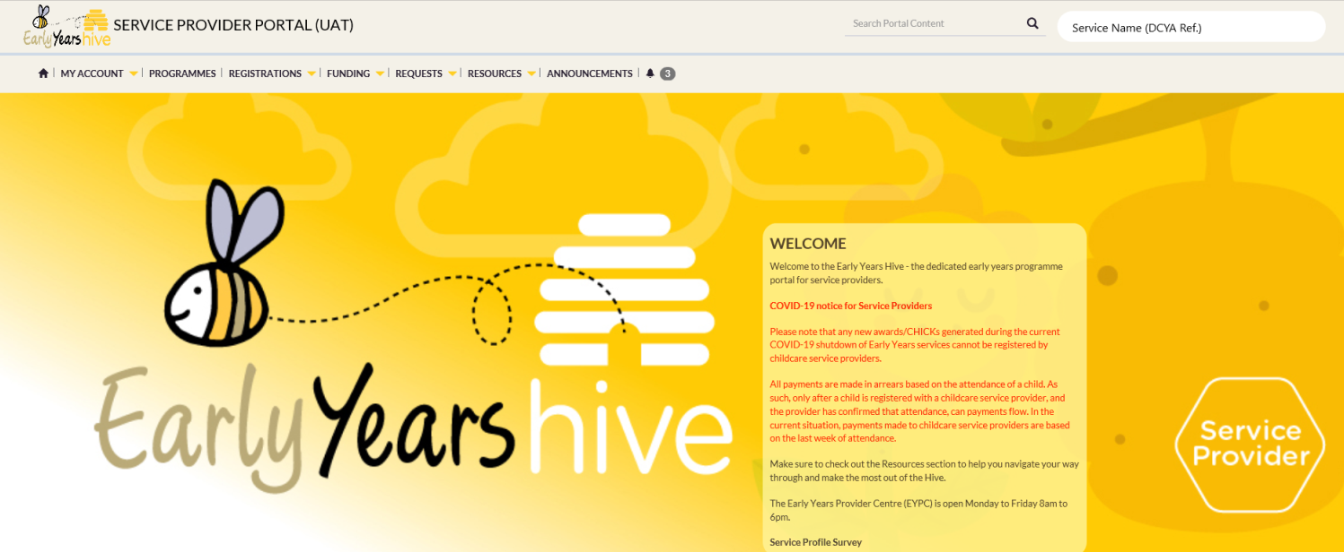

(As noted above, a service profile should be completed for each facility, i.e. one for each DCYA reference number.)

|  |
| --- |
| **Note:** The survey will automatically save as you work on it, so you can complete it in multiple sittings. To save and close the survey, simply exit the browser window. You can reopen it by clicking back into the link in PIP and/or EYP.  You can also close and save as draft by clicking the ***Save and exit*** button. This is available on all pages and will exit you out of the survey. To return, please reopen the link on your PIP/EYP homepage. |

## Navigating and saving the Service Profile

|  |  |
| --- | --- |
| ***Icons (top of each section)*** | ***Action*** |
|  | *Previous* |
|  | *Sections list* |
|  | *Next* |
|  | *Close* |
|  | *Save and exit* |
|  | *Submit* |
|  | *Full screen* |

To navigate from one section to another, click the ***Previous*** / ***Next***  icons.

**Note**, if there are any unanswered questions in the section you are in, and you click the ***Next*** icon, you will see the following message:

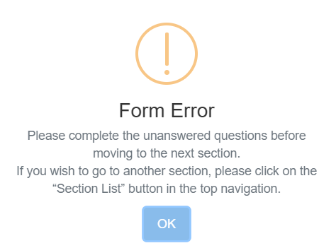

This will highlight any questions that have either missing or incorrect responses.

To exit a section and move to the next without completing it, return to the ‘**Section list**’ by clicking this icon at the top of the page:



To save the form as draft, you simply need to close the browser. You can also save and exit by clicking the ***Save and exit*** icon and the following message will appear.

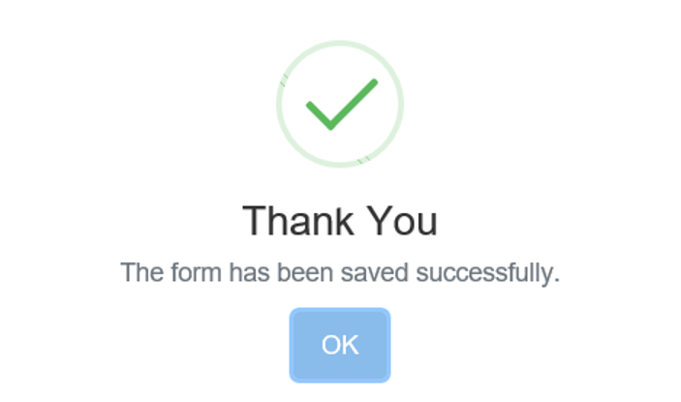

## Note on completing multiple Service Profiles

One service profile should be completed for each service (i.e. one per DCYA Reference number). Each service has their own unique survey link, which can be accessed through their PIP/EYP profile.

For group organisations or facilities with multiple services, please note that you cannot open or complete multiple service profiles at the same time. If you do, you may encounter problems saving or see the following error message:

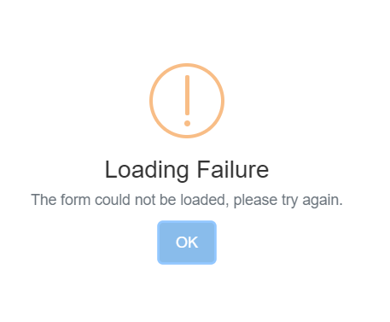

If you do need to work on more than one survey at a time, please ensure you have saved and exited one survey before opening the other.

# Service details

This section requires the following information:

## General

DCYA ref:  
(Automatically completed for all facilities.)

Facility name:  
(Automatically completed for all facilities.)

Please check that the DCYA Ref. and the name of your facility are correct before you start completing the form. If these details are not correct please contact [EYPC@pobal.ie](mailto:EYPC@pobal.ie).

Community / Private:  
(Automatically completed for all facilities.)

Is your service billed for rates?  
Must select '***Yes/No***'.

Most recent/last annual rate €:  
Must insert figure if '***Yes***' selected in previous question, above.

Figure must be between €1 - €200,000.

Does your service pay mortgage, rent, or licensing fees for the use of the premises?

Must select '***Yes/No***/***Don’t know’***.

Average monthly rent/mortgage/licensing payment

Must insert figure if '***Yes***' selected in previous question, above.

Figure must be between €1 - €10,000.

Annual childcare insurance cost for the service

Note: Please provide the cost of childcare insurance only.

Figure must be between €1 - €100,000.

Does the service provide early learning and care through the medium of Irish? Must select '***Yes/No***'.

Does the service provide food for the children?

Must select '***Yes/No***'.

Is the food prepared on the premises or sourced externally?

Must select one of the following options if '***Yes***' selected in previous question, above:

|  |
| --- |
| Prepared on the premises  Sourced externally |

Does your service have an outdoor play area on its premises?  
Must select '***Yes/No***'.

## Disability/ Equality/ Inclusion

To the best of your knowledge, how many of the following make use of your service?  
**Must enter whole number between 0 and 250 for each category.**

Number entered in any ‘***ECCE***’ field cannot be greater than the number entered in corresponding ‘***All***’ field.

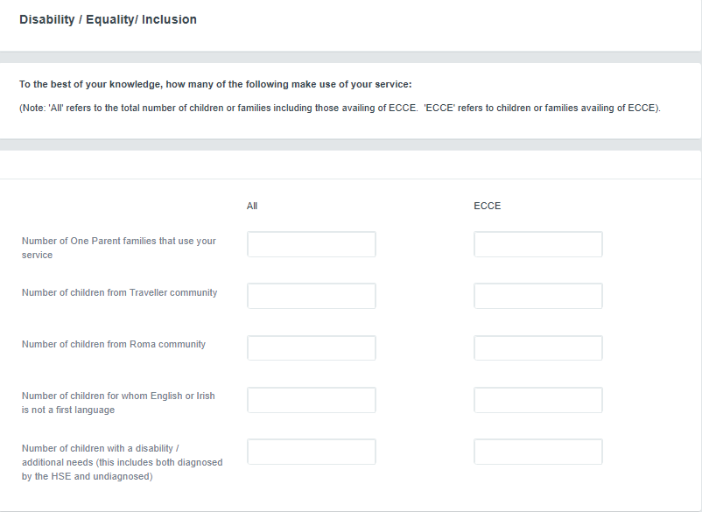

Total number of children with a disability/additional needs diagnosed by the HSE:  
Must enter whole number between 0 and 250.

Number cannot be greater than ‘***Number of children with a disability / additional needs (this includes both diagnosed by the HSE and undiagnosed) – All***’ in the previous table.

Children with a disability / additional needs diagnosed by the HSE:  
Must enter whole number.

If none in particular category, please enter ‘***0****,*’ or figure **no greater than 250.**

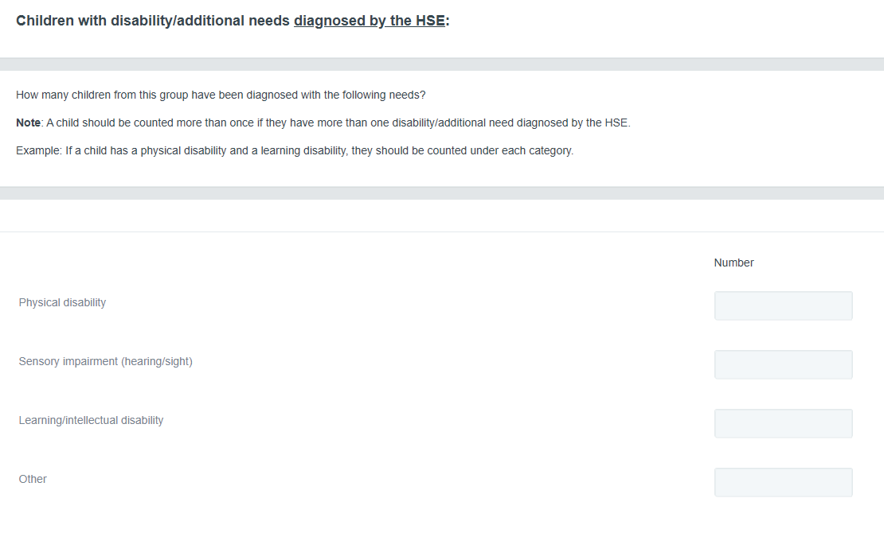

How many children from this group have more than one disability / additional need diagnosed by the HSE?  
Number cannot be greater than ‘***Total number of children with a disability / additional needs diagnosed by the HSE*’**.

Please state if your service is wheelchair accessible as outlined in the Disability Act 2005:  
Must select 'Yes/No'.

# Capacity and attendance

This section requests data on the number of places your service is in a position to offer, by service type(s) and age range, and weekly fee(s).

**Please complete the details / figures as they were prior to the Covid-19 closures.**

## Service type

**Please indicate the number for the following (for ALL places) by service type(s): for children of all ages**

Yes/No:  
Must select '***Yes/No***' from each dropdown under this heading to indicate whether you offer this type of service.

You must select ‘***Yes***’ for at least one service type.

If you select ‘***Yes***’, you must complete the corresponding fields under the headings:

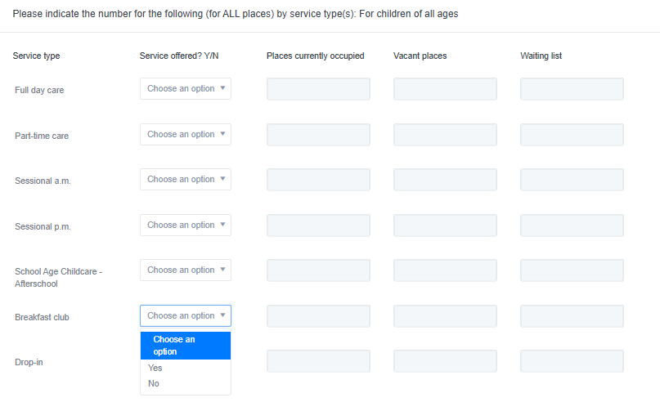

A child may be counted under **full day care** if they occupy a childcare place for a **full day** for 1 – 5 days (inclusive) a week.

|  |
| --- |
| **Example:** A child attending for two full days a week may be counted once under full day care. Another child attending for five full days a week may also be counted once under full day care. |

A **sessional a.m. or sessional p.m.** service is any service offering childcare places for child(ren) that spend a morning **or** afternoon in that service for 1 – 5 days (inclusive) a week.

A child may be counted under **part-time care** if they spend less than a full day and more than a session, in that service for 1 – 5 days (inclusive) a week.

**Places currently occupied** – How many children are enrolled **and** currently occupy a place in your facility? (List ALL children including those registered on DCYA Programme(s) e.g. NCS, ECCE, CCS/P and TEC).

**Vacant places** – The number of places your service is currently in a position to offer per day, minus the current number of places occupied. (This may/should not exceed the maximum capacity as set out in a Tusla Inspection Report, where available).

**Waiting list** – How many children on your service’s waiting list require a place **immediately**? (If you have no children on a waiting list, or do not have a waiting list, please enter zero.)

Places currently occupied:  
Must enter figure between **1-500** (inclusive).   
(Note: ***Total:*** (figure) will total all figures entered under this heading, automatically.)

Vacantplaces:  
Must enter figure between **0-500** (inclusive).

Waitinglist:  
Must enter figure between **0-500** (inclusive).

**Please indicate numbers for the following (For ALL places) - by age range:**

Yes***/***No:  
Must select '***Yes/No***' from each dropdown under this heading to indicate whether you cater for this age range.

You must select ‘***Yes***’ for at least one age range.

If you select ‘***Yes***’, you must complete the corresponding fields under the headings:

Places currently occupied:  
Must enter figure between **1-500** (inclusive).

Vacantplaces:  
Must enter figure between **0-500** (inclusive).

Waitinglist:  
Must enter figure between **0-500** (inclusive).

**Note:** There are separate rows for ***schoolgoing*** and ***non-schoolgoing*** children aged 4-5 and 5-6 years.

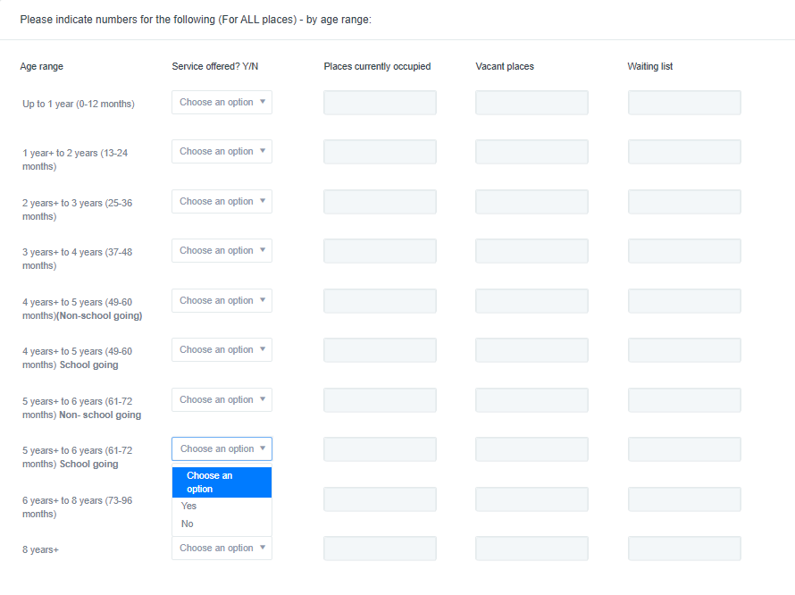

**Note**: Total number of children enrolled by '***Service type'*** should be equal to or greater than the number of children enrolled by '***Age range'***.

## Weekly fees

This table asks for weekly fee data on any full day care, part-time care and sessional services that **you currently provide** for each age range.

**This table must correspond with the information you have already provided on the numbers of places currently occupied in your service.**

**Example:**

|  |
| --- |
| You stated that your service currently provides full day care and a sessional a.m. service. You have also stated that you provide care for children from 1-2 years, 2-3 years and 3-4 years. You need to state the average weekly fee for full day care and/or sessional services for each of these age ranges. |

The weekly fee for **full day care** for each age range should be based on 1 child attending 5 days a week for a full day. If you charge different fees for children in the same age range, just provide the average weekly fee.

Note: We appreciate not all children availing of full day care will attend for the full 5 days. In these cases, please calculate what their weekly fee would be if they attended for all 5 days a week.

**Example:**

|  |
| --- |
| 1 child attends your service 5 full days a week and pays €300 a week.  1 child attends your service 3 full days a week and pays €200 a week (this would work out as €333 if that child attended 5 days a week)  The average weekly full day care fee is: €316.50 (=(€300 + €333) ÷ 2) |

The weekly fee for **sessional services** should also be based on 1 child attending 5 days a week. If you charge different fees for children of the same age range, just provide the average weekly fee.

**Example:**

|  |
| --- |
| Your services charges €80 a week for a sessional a.m. service for 3 – 4 year olds and €70 for the sessional p.m. service for this age group.  You should enter €75 (=(€80 + €70) ÷ 2). |

The weekly fee for **part-time services** for each age range should, again, also be based on 1 child attending 5 days a week. If you charge different fees for children in the same age range, just provide the average weekly fee.

**Do not deduct subventions from the weekly fee table.**

**Example:**

|  |
| --- |
| If you charge €150 for a full-time place, and the child receives €69 ECCE subvention, you should enter €150. |

Please indicate weekly fee before deductions (for the following age ranges and service types) for non-schoolgoing children only:  
Must enter figure between **1-600** (inclusive).

**Please provide the average weekly fee** for age ranges and service types you provide in your service (i.e., those you have said ‘**Yes**’ to in the two preceding tables: ***Numbers by service type*** and ***Numbers by age range for non-schoolgoing children only)***.

You will only be able to provide fee figures for the services types and age ranges selected in the previous tables. **Note: In the event that a field opens up for a service type/age range combination you do not provide, please enter a ‘1’ into this field**.

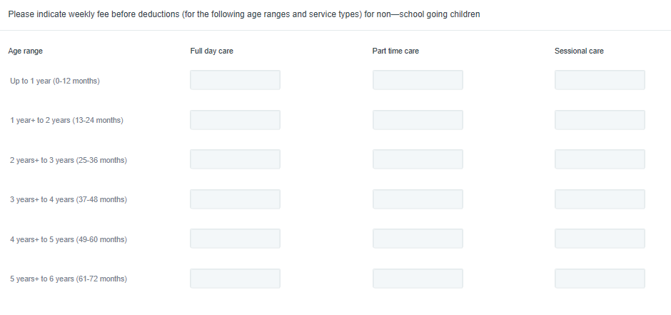

Do you offer school age childcare – in term (after-school)?

Must select '***Yes/No***'.

If ‘Yes’, what is the hourly fee € (before deductions*)  
Must enter figure between **1-15** (inclusive), if said ‘***Yes***’ to question above.

*Do not deduct any subventions.

Do you offer school age childcare – outside term?  
Must select '***Yes/No***'.

If ‘Yes’, what is the weekly fee € (before deductions*)

Must enter figure between **1-300** (inclusive), if said ‘***Yes***’ to question above.

*Do not deduct any subventions.

Number of hours per week your service operates (i.e. is open to children):

In term  
Must enter figure between **1-100** (inclusive).

Outside term  
Must enter figure between **0-100** (inclusive).

Number of weeks per year service is operational  
Must enter whole numbers between 30-52 (inclusive).

# Staff: Managerial

**Note:** There are three separate staff sections for ***Managerial***; ***Staff working directly with children*** and ***Ancillary staff***. As you must have at least one staff member working directly with children in your service, the total number of managerial staff plus staff working directly with children must be more than 0.

Please complete a section for every manager, including those working directly with children.

**Please enter managerial staff figures as they were prior to the Covid-19 closures.**

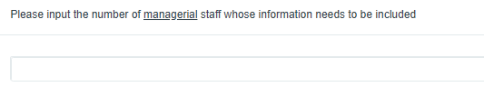

Once you have entered the number of managerial staff, you will see that headings for each managerial staff member were created. Select the ‘**+**’ symbol to expand the questions for each manager. All questions in this section need to be completed.

Please see details of dropdown lists/validations for all the questions listed under Managerial Staff:

Job Title  
Must select option which best reflects the position of each manager:

|  |
| --- |
| Centre Manager Deputy Manager |

Please indicate what type of manager role this person holds:

Must select option which best reflects the position of each manager:

|  |
| --- |
| Owner-manager (owner operator) Manager employed by the service |

Does this manager also work directly with children?  
Must select ***'Yes/No'***.

### Category of children this staff member works with (please choose primary category of children staff member works with only)?

Must select one of the following options if '***Yes***' selected in previous question, above:

|  |
| --- |
| Up to 1 year  1 year+ to 3 years 3 years+ to 5 years 5+ years |

Is this manager on an hourly wage or an annual salary?  
Must select one option:

|  |
| --- |
| Hourly wage  Annual salary  Other (e.g. drawing non-fixed income from business) |

***Please give details of the hourly wage for this manager €:***

Must insert figure if ***'Hourly wage***' selected in previous question, above.

Figure must be between €1 - €70.

*If the manager is not on a specific hourly wage, consider their gross income for the last full month they worked (prior to the COVID-19 closure) and divide it by the number of hours worked during that period of pay.

***Please give details of the annual salary for this manager €:***

Must insert figure if ***'Annual salary***' selected in previous question, above.

Figure must be between €1 - €120,000.

***Please give details of the estimated annual income for this manager from the business€:***

Must insert figure if ***'Other (e.g. drawing non-fixed income from business)***' selected in previous question, above.

Figure must be between €1 - €150,000.

Average number of contact hours worked per week:

(i.e. hours spent working directly with children)  
Must enter a figure between 0-84 (inclusive) if answered ‘Yes’ to also working directly with children.

Average number of non-contact hours worked per week:

*(i.e. hours spent on administrative or other work, when not working directly with children)*  
Must enter a figure between 0-84 (inclusive)

***How many weeks per year are paid for this manager (including holidays and other leave entitlements)?***

Must enter a figure ***between 0-52 (inclusive)***

Country in which the staff member acquired their Early Years qualification  
Type in the country the staff member acquired their qualification and/or select from dropdown. If the staff member has no Early Years qualification, select ‘No early years qualification’ from this dropdown list.

Highest Early Years Qualification:  
For qualifications, please provide information only on Childcare/Early Years Major Awards that have been **completed**.  
Must select one of the following:

|  |
| --- |
| No early years qualification NFQ Level 4 NFQ Level 5 NFQ Level 6 NFQ Level 7 NFQ Level 8 NFQ Level 9/10 |

Is in the process of qualifying for an Early Years qualification?  
Must select ***'Yes/No'***.

Qualification in the process of qualifying for:   
If ‘Yes’ to previous question, must select one of the following:

|  |
| --- |
| NFQ Level 5 NFQ Level 6 NFQ Level 7 NFQ Level 8 NFQ Level 9/10 |

Does this manager hold any relevant non-childcare qualifications?  
Mustselect ***'Yes/No'***.

Please select the qualification type:   
If ‘Yes’ to previous question, must select one of the following:

Note: If this manager has more than one non-childcare qualification, please select the one with the highest NFQ level.

|  |
| --- |
| Management  Business  Finance  HR  Other |

Please select the qualification level:   
If ‘Yes’ to previous question, must select one of the following:

|  |
| --- |
| NFQ Level 5 NFQ Level 6 NFQ Level 7 NFQ Level 8 NFQ Level 9/10 |

Employment scheme/ government funded programme (if applicable):   
Must select one of the following (**Note**: Different options for **Community** and **Private** services):

|  |
| --- |
| **Community services only options**: Not applicable  CE - Community Employment  CSP - Community Services Programme  JI - Job Initiative Scheme  JobsPlus  Tús  YESS – Youth Employment Support Scheme  **Private services only options**: Not applicable JobsPlus  YESS – Youth Employment Support Scheme |

(Note - This question above and the one below, will only appear if ‘***Yes***’ has been selected to ‘Does this manager also work directly with children?’)

Signed Grandfather Declaration:  
Mustselect ***'Yes/No'***.

Length of time working in this current service:Must select one of the following:

|  |
| --- |
| Under 1 year 1-2 years 3-4 years 5-10 years 11-20 years 20 years + |

Length of time working in the early years sector:  
Must select one of the following:

|  |
| --- |
| Under 1 year 1-2 years 3-4 years 5-10 years 11-20 years 20 years + |

**Note:** If you need to temporarily exit this section before entering all data for each manager, you can return to the section list by clicking this icon at the top of the page:



# Staff: Working with children

**Note:** There are three separate staff sections for ***Managerial***; ***Staff working directly with children*** and ***Ancillary staff***. As you must have at least one staff member working directly with children in your service, the total of managerial staff and staff working directly with children must be more than 0.

**Please enter staff figures as they were prior to the Covid-19 closures.**

Each service must submit the required details for each **staff member** who works directly with children.

Please make sure you have also included information about yourself if you work directly with children, unless you are also a manger (in which case you should enter yourself in under ***‘Managerial Staff’*** in the previous section).

To complete this section, input the number of **staff working directly with children** in your service in this field:

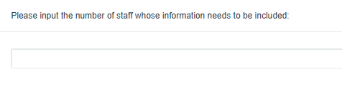

Once you have entered the number of staff, you will see that a new heading created below for each staff (as shown below).

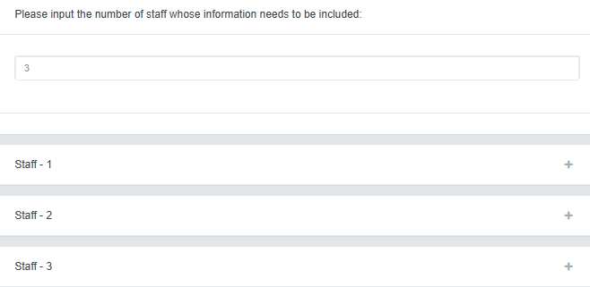

Select the ‘**+**’ symbol to expand the questions for each staff member. All questions in this section need to be completed.

Please see details of dropdown lists/validations for all the questions listed under Staff working with children:

Job Title  
Must select option which best reflects the position of each staff member:

|  |
| --- |
| Room Leader (ECCE) Room Leader (non-ECCE) Early Years Assistant (ECCE) Early Years Assistant (non-ECCE) Student Placement/ Volunteer Relief / Cover |

Country in which the staff member acquired their Early Years qualification  
Type in the country the staff member acquired their qualification and/or select from dropdown. If the staff member has no childcare qualification, select ‘No early years qualification’ from the dropdown list.

Highest Early Years Qualification:  
For qualifications, please provide information only on Childcare/Early Years Major Awards that have been completed.  
Must select one of the following:

|  |
| --- |
| No early years qualification NFQ Level 4 NFQ Level 5 NFQ Level 6 NFQ Level 7 NFQ Level 8 NFQ Level 9/10 |

Is in the process of qualifying for an Early Years qualification?  
Must select ***'Yes/No'***.

Qualification in the process of qualifying for:   
If ‘Yes’ to previous question, must select one of the following:

|  |
| --- |
| NFQ Level 5 NFQ Level 6 NFQ Level 7 NFQ Level 8 NFQ Level 9/10 |

Average number of contact hours worked per week:  
Mustenter a figure between 0-84 (inclusive).

Note: if staff member works 40 hours, but is contracted to work 36, please enter 40.

Average number of non-contact hours worked per week:  
Must enter a figure between 0-84 (inclusive).

Is this staff member on a seasonal contract (e.g. 38-42 week contract):  
Must select 'Yes/No'.

Does this staff member work with school-going children only?  
Must select 'Yes/No'.

What type of contract does this staff member have?   
Must select one of the following:

|  |
| --- |
| Permanent Temporary |

Employment scheme/ government funded programme (if applicable):   
Must select one of the following (**Note**: Different options for **Community** and **Private** services):

|  |
| --- |
| **Community services only options**: Not applicable  CE - Community Employment  CSP - Community Services Programme  JI - Job Initiative Scheme  JobsPlus  Tús  YESS – Youth Employment Support Scheme  **Private services only options**: Not applicable JobsPlus  YESS – Youth Employment Support Scheme |

Signed Grandfather Declaration:  
Mustselect ***'Yes/No'***.

Category of children this staff member works with (please choose the primary category of children staff member works with only):Must select one of the following:

|  |
| --- |
| Up to 1 year 1 year+ to 3 years 3 years+ to 5 years 5+ years |

Length of time in this current service:Must select one of the following:

|  |
| --- |
| Under 1 year 1-2 years 3-4 years 5-10 years 11-20 years 20 years + |

Length of time working in early years sector:  
Must select one of the following:

|  |
| --- |
| Under 1 year 1-2 years 3-4 years 5-10 years 11-20 years 20 years + |

Please state the average hourly wage* of this staff member:  
*If the staff member is not on a specific hourly wage, consider their gross income for the last full month they worked (prior to the COVID-19 closure) and divide it by the number of hours worked during that period of pay.

Must enter a value between **0-70** (inclusive), unless the staff member is a student placement / volunteer (in which case the question will not appear on the form).

**Note:** If you need to temporarily exit this section before entering all data for each staff member working with children, return to the section list by clicking this icon at the top of the page:



# Ancillary staff (those NOT working directly with children)

**Please enter staff figures as they were prior to the Covid-19 closures.**

To add ***Ancillary (those NOT working directly with children) staff***, select ***Insert item*** under that heading:

To complete this section, input the number of **ancillary staff** in your service in this field:

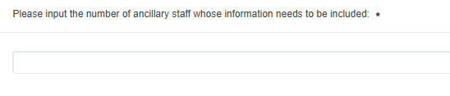

Once you have entered in the number of staff, you will see that a new heading created below for each staff member.



Select the ‘**+**’ symbol to expand the questions for each staff member. All questions in this section need to be completed.

Please see details of dropdown lists/validations for all the questions listed under Ancillary staff.

Please see details of dropdown lists/validations for all the questions listed under Ancillary (those NOT working directly with children) staff:

Job title  
Please select option which best reflects the position of each staff member:

|  |
| --- |
| Admin/Clerical Catering Maintenance Student Placement / Volunteer Transport |

Employment scheme/ government funded programme (if applicable):  
Must select one of the following (**Note**: Different options for **Community** and **Private** services):

|  |
| --- |
| **Community services only options**: Not applicable  CE - Community Employment  CSP - Community Services Programme  JI - Job Initiative Scheme  JobsPlus  Tús  YESS – Youth Employment Support Scheme  **Private services only options**: Not applicable JobsPlus  YESS – Youth Employment Support Scheme |

Please state the average hourly wage* of this staff member:  
*If the staff member is not on a specific hourly wage, consider their gross income for the last full month they worked (prior to the COVID-19 closure) and divide it by the number of hours worked during that period of pay.

Must enter a value between **0-70** (inclusive) unless the staff member is a student placement or volunteer (in which case the question will not appear on the form).

## Deleting or editing the number of staff members

If you have entered too many staff members in any of the staff sections, simply return to the count of staff and reduce the number down to the correct amount.

You cannot delete a staff member from this section once answers have been provided. If you do try to reduce the number of staff in any of the staff sections after filling out some of the questions, you will see the following error message:

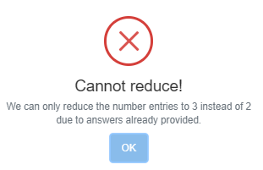

If you have incorrectly added a manager or staff member and are unable to delete them, please contact us at [EYPC@pobal.ie](mailto:EYPC@pobal.ie).

To add a member of staff, return to the count of staff members and increase the number to the desired amount.

# Vacancies/ Turnover (staff working directly with children only)

How many staff have left your service in the previous 12 months?   
Must enter figure between 0-50 (inclusive).

To the best of your knowledge, how many of the above staff have:

Moved to another service provider:  
Must enter whole number.

Left the early years sector:  
Must enter whole number.

Left Ireland:  
Must enter whole number.

Don’t know:  
Must enter whole number.

**Note**: The total sum of staff who have ‘***Moved to another service provider***’, ‘***Left the early years sector***’, ‘***Left Ireland***’ or ‘***Don’t know***’ must equal the number of staff in the previous question*: ‘*How many staff have left your service in the previous 12 months?’

**Total number of staff who left**: This gives an automatic running total of all staff entered under each of the four categories of staff that left, in last question, above.

Of the staff that left, please indicate what level of qualification they had:

Must enter ***whole number***.

The total number of staff must equal the number of staff in **“**How many staff have left your service in the previous 12 months***.”***

|  |  |
| --- | --- |
| Qualification | Number of staff that left |
| NFQ Level 4/ no qualification |  |
| NFQ Level 5 |  |
| NFQ Level 6 |  |
| NFQ Level 7 or above |  |
| Don’t know |  |

|  |  |
| --- | --- |
| ***Total number of staff who left*** | *(Sums above fields automatically)* |

How many staff vacancies did you have prior to the Covid-19 closures on March 12th?

Please categorise the number of staff vacancies in your service by staff qualification:  
Must enter figure between ***1-50*** (inclusive), if 1 or greater entered for previous question above.

The total number of staff must equal the number of staff in **“**How many staff vacancies did you have prior to the Covid-19 closures on March 12th?***”***

|  |  |
| --- | --- |
| Qualification/ position | Total staff vacancies |
| NFQ Level 5 |  |
| NFQ Level 6 |  |
| NFQ Level 7 or above |  |
| AIM Level 7 Support |  |

|  |  |
| --- | --- |
| Total staff vacancies by qualification | (Sums above fields automatically) |

Average number of weeks taken to fill vacancies for staff, in the last 12 months:Must enter a figure between ***0-52***, inclusive.

In the last 12 months, have you experienced challenges in relation to recruiting suitably qualified staff?  
Must select 'Yes/No'.

Have you actively recruited/advertised for staff living overseas in the past 12 months?  
Must select 'Yes/No'.

# Covid-19 Activities

Please tell us any ways in which you have continued to support children’s learning during the period of Covid-19 closures.  
Please insert wording, max 150 words.

# Declaration

Name:  
Please enter in the name of the person who completed the survey. If multiple people have inputted data, then please enter in the name of the person assuming overall responsibility for the information provided.

Pobal reserves the right to make contact with the respondent for the purpose of data quality and verification.

Date:  
Field will also automatically default to the current date/date the service profile is being completed.

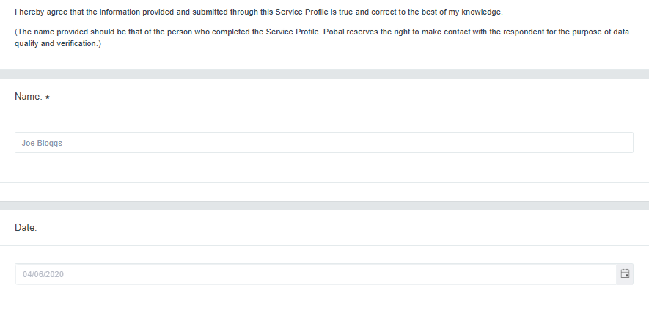

# Submission of Service Profile

When you are satisfied that the information provided is complete and accurate to the best of your knowledge, you can submit your service profile.

You can do this by clicking the ‘***Submit***’ icon, which can be found at the top of each page in the survey:

Submit icon: 

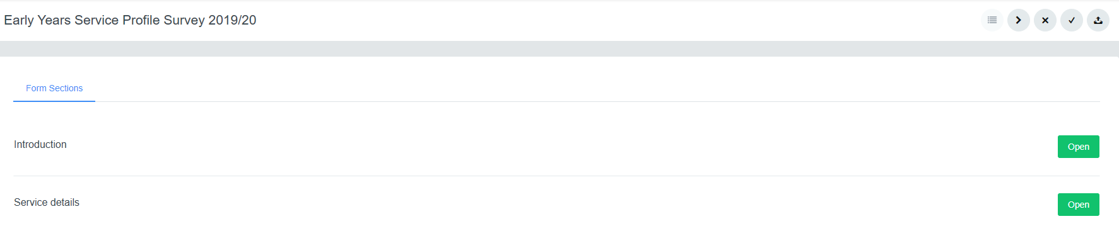

If you try to submit an incomplete survey, the following message will appear on screen:

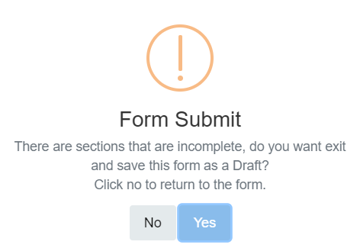

This means there are questions with either missing or incorrect responses (e.g. an amount that is outside of the accepted range for that question).

Click ‘***No***’ to return to and review the survey. Any missing or incorrect responses will be highlighted in red within the individual sections, so you will need to review each section for any errors.

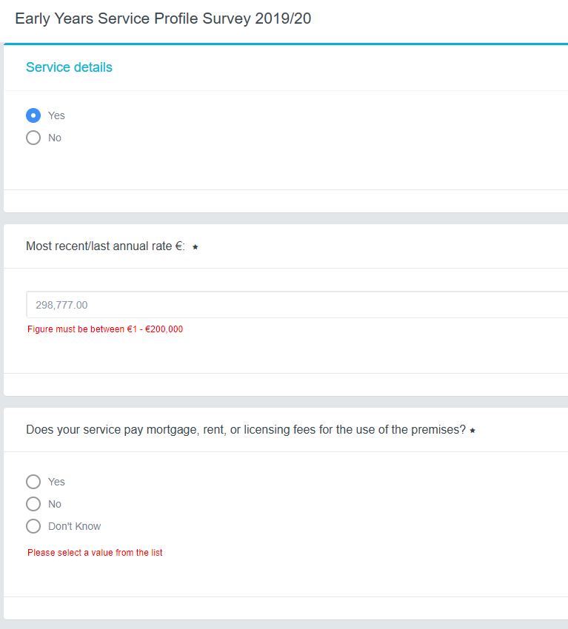

Missing response

Incorrect response

Once you have moved through each section and addressed each missing/incorrect item, you will be able to submit the service profile. You will then see the following message:

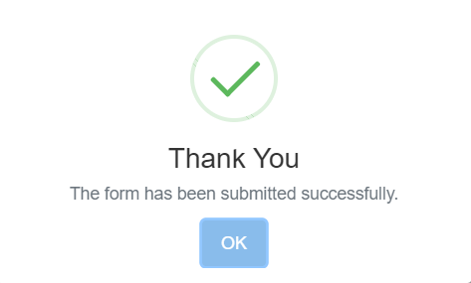

You cannot edit a form after it has been submitted.