Laois Childminder Newsletter February 2022
What’s Happening:
- Upcoming Childminder Network
Building connections between the child and the childminder
Online session on Tuesday 5 April
7-8.30pm
To book your free place:
Email: m.nolan@laoischildcare.ie or call 057 8661029 for more information
Starting with a new Childminder is a major life change for young children, their families and for you as a Childminder. Settling in with a new Childminder always needs careful consideration, but the last 2 years of Covid restrictions have impacted the process of separation from parents more than ever. In this discussion with Childminders, Joanna will help us to understand what is going on for the child and how we can help manage the period of adjustment for everyone’s benefit.
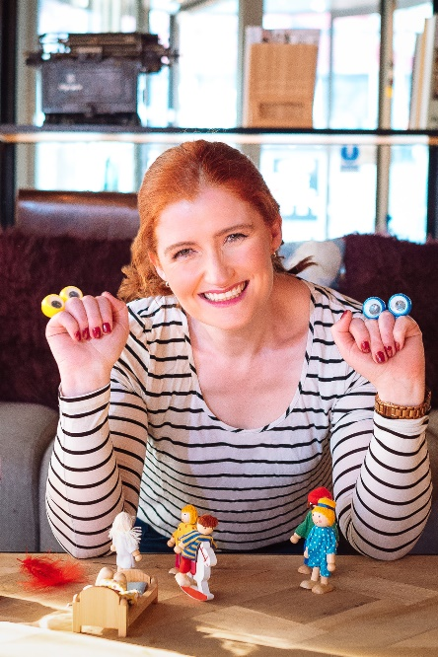
Joanna Fortune is an accredited psychotherapist and attachment specialist. She is the author of the best-selling 15-Minute Parenting series of books (0-7 years; 8-12 years and the Teenage years. She is the host of the 15-Minute parenting podcast and founded the Solamh Parent Child Relationship Clinic in Dublin in 2010 (www.solamh.com)where she has worked with families around a variety of issues. She writes and contributes to articles on child development and parenting in print publications and is also a regular media contributor to a variety of radio (RTE, Newstalk and
regional radio) and TV shows (RTE and Virgin Media Television). She is the parenting consultant on the weekly parenting slot on Newstalk’s Moncrieff for over 4 years.

Instagram: @joannafortune
Twitter: @imJoannaFortune
https://solamh.com

- Book Bag Collection

Calling all childminders and those who wish to become a childminder minister Roderic O’Gorman has launched the Little Libraries Initiative – Free Book Bags for Childminders in conjunction with the National Action Plan. As part of the Launch, we are delighted to invite you all to collect your FREE bag of books from Portlaoise Library on Tuesday 15th of march from 10.30 – 12.00 am.
The Childminding Little Libraries Initiative - supports childminders to develop little libraries in their homes with quality book titles in English and Irish. The focus of this initiative is to support early language and literacy development, and the establishment of links between childminders and libraries.

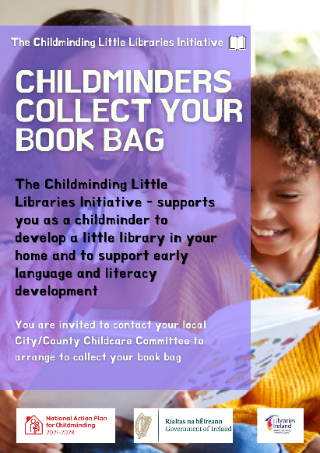
- Story Telling Activity
Please see image of our February Story-telling activity in Portlaoise Library.
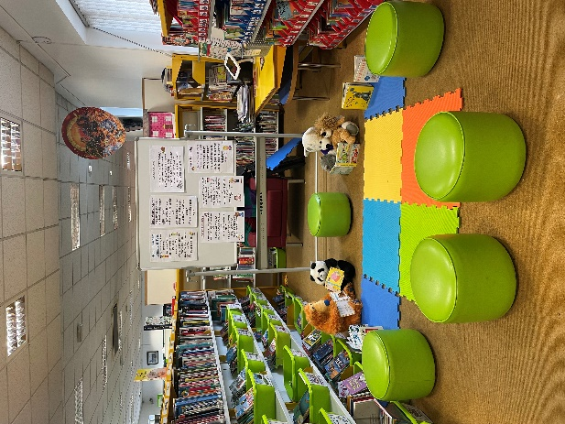
- Covid Guidance for Childminders
20220225 DCEDIY Update effective 28th February.pdf Public Health advice for the management of cases and contacts of COVID-19.pdf
- Activity Idea
https://first5.gov.ie/userfiles/pdf/treasure-hunt.pdf
